USER MANUAL

PLATFORM FORECASTS AND CLIMATE Agroclimatic

Product # 1 - USAID

WRITTEN BY:

STEVEN SOTELO

EDWARD GUEVARA

JEISON MESA

DECISION AND POLICY ANALYSIS - DAPA

International Center for Tropical Agriculture - CIAT

CALI

2017

Table of Contents

1. WEB PORTAL OF DIRECTORS 3

1.1. Administration 3

1.1.1. users 4

1.1.2. Sources 5

1.2. Geography 5

1.2.1. state 6

1.2.2. Municipalities 11

1.2.3. Seasons 11

1.3. Production 15

1.3.1. Crops 15

1.3.2. cultivars 19

1.3.3. floors 20

1.4. to import 21

1.4.1. historical climate 2121

1.4.2. Climatology 22

1.4.3. Historical production 24

2. FORECASTS generation process 25

# WEB PORTAL OF DIRECTORS

The aim of this portal is to allow the parameterization of the platform forecasts. The changes made in this website directly affected the process of generating forecasts and data available through the web service, thus also affect the website display forecasts.

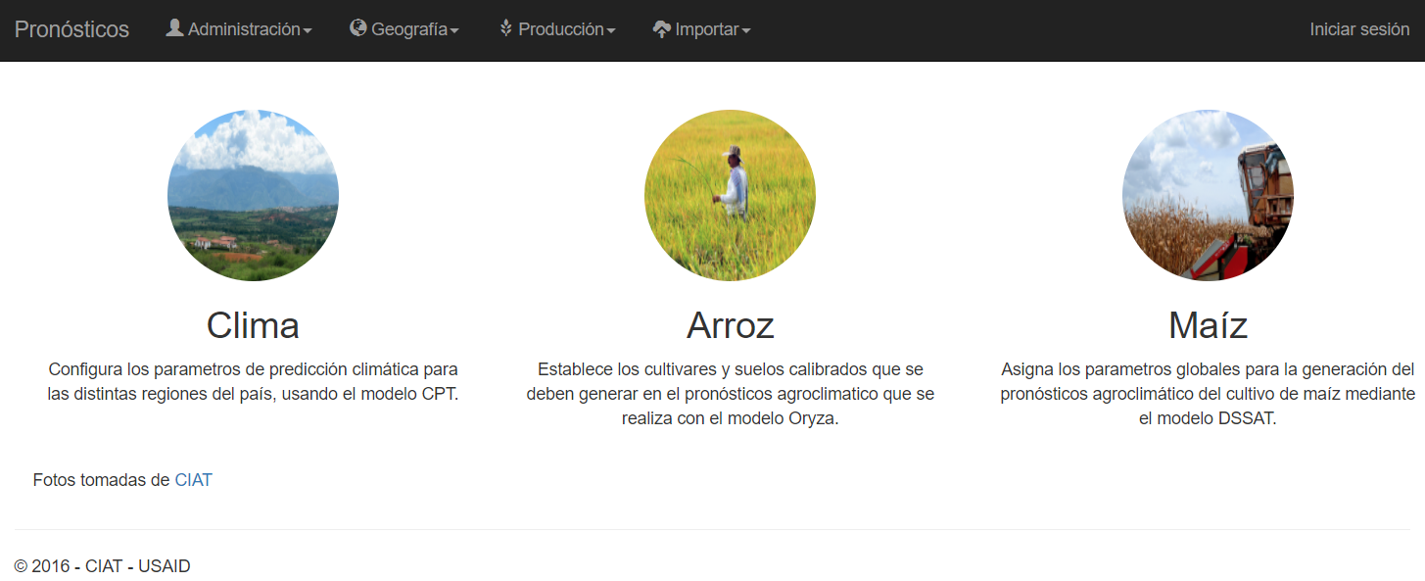

Illustration 1 Home Administration website

In the following sections the main menu options detailing the application and what role they play within the system. It is recommended that for initial parameterization of the system the order specified in this document will follow.

Within this web site you can add, edit, delete and list all information on system parameters. There are two types of deletions, logic and other physics. The logical deletion keeps the information in the database, but not the leaves available on the platform. Physical removal completely deletes the record in the database. Deletions in the various modules can be logical or physical, each which is described how to perform this process.

Each entity participating in the platform contains a field that identifies each record in the database. These fields can be mandatory or not. Each module describes the meaning of these and indicates whether they are mandatory or not. Fields identifiers (id) records are self-generated by the system. Each record in the database contains an identifier.

## Administration

This section allows management of global parameters related to users of this web application implementation and sources of historical production data.

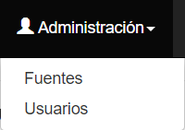

Illustration 2 Administration menu

### users

#### roles

The roles define the set of actions that can be performed or not in the application. Users need to have associated one or more roles to access the various modules. Roles are predefined by the application and no option to edit. Roles are available in the application:

* ADMIN: Allows access to all application modules.
* CLIMATOLOGIST: Allows access to modules geographical and climate forecasts settings.
* IMPROVER: Allows access to modules crops and agro-climatic settings forecasts.
* TECH: Allows access to user management.

In each of the modules to be detailed hereinafter, the roles that have access to this module specific.

#### User administration

User management to manage who can access the web administration portal. You can add, edit and list users available on the web management portal. Users can not be deleted from the database, if what you want is not to allow user input to the system, this must be disabled in the option to edit.

During registration of a new user, you must provide an email address, to which it will be sent a welcome message with a link to confirm the account. The application does not allow you entry immediately, but must make a confirmation email by clicking on the link in the message sent by the system. In the register only allowed to select a single Role, however Edition user, you can add or remove user roles.

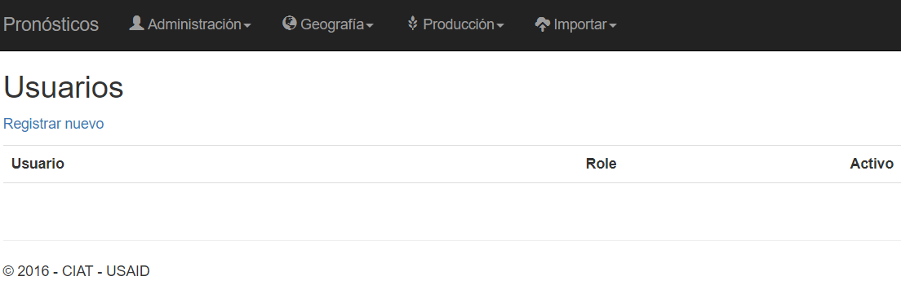

Illustration 3 Users module

Required fields:

* The email is an active email account
* The password is the user password to enter the platform
* Roles define the user profile as sites access

This option is available for users who have the roles of ADMIN TECH.

### Sources

Sources are used to define the source of historical production data. It is necessary that before importing historical data from crop production, define what is the source from which comes the information. In this module you can add, edit, delete and list the data available in the database. Disposal in this module is logical.

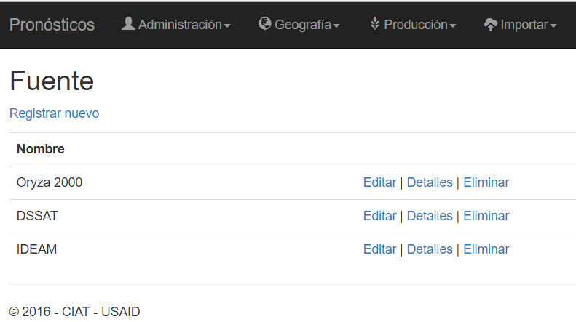

Illustration 4 Supply Module

Required fields:

* The name is a description of the source

This option is available for users who have the roles of ADMIN, CLIMATOLOGIST, IMPROVER.

## Geography

This section allows management of geographical parameters of the application. As for geographic location can be managed: states (departments), municipalities and weather stations.

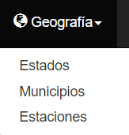

Illustration 5 Geography menu

### state

In the module states (departments) which allows administration of these are available or not on the platform forecasts. Here you can add, edit, delete and list all the departments that are in the system. Disposal in this module is logical.

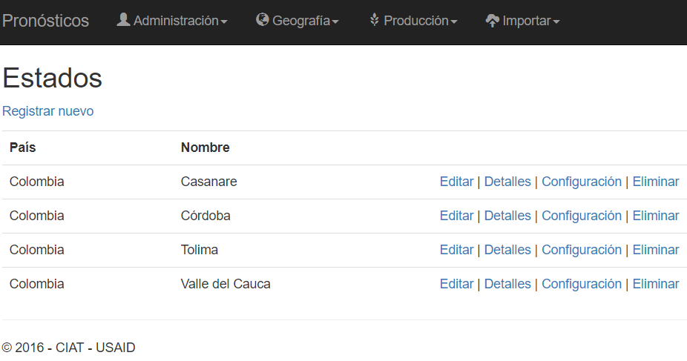

Illustration 6 module states

Required fields:

* The country's name is the name of the country to which the state belongs
* The code ISO 2**[1]** It corresponds to international ISO code that is assigned to each country
* The state's name is the proper name of the state or department

To prevent the registration of each municipality and weather station, the system allows importing from a flat file in CSV format the list of all municipalities and weather stations that are associated with each state. The details of how to do this is described later in this section.

The process of generating climate prediction requires performing a parameterization for the implementation of CPT. This configuration is done by state and affects all weather stations associated with this. In later sections detailing how to perform this process.

This option is available for users who have the roles of ADMIN, CLIMATOLOGIST.

#### Import municipalities and seasons by department

To access this option, you must enter the module states, then click on the link status details that you want to charge municipalities and stations, the application will take you to see the details of the selected state. Once you are there you can see the Import link, you must click there.

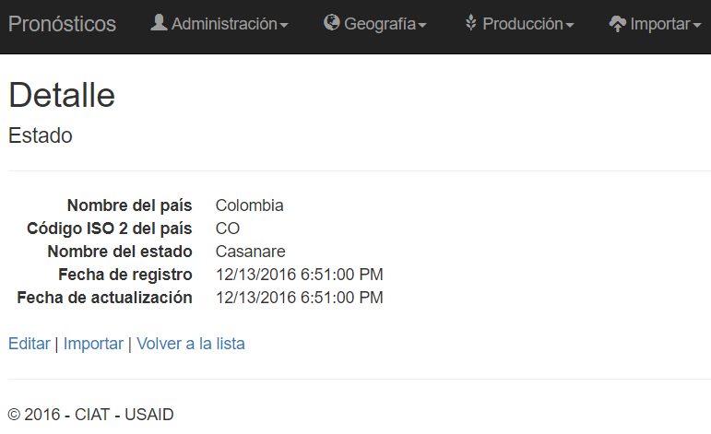

Illustration 7 Detail Status

Once there you can see a summary of the state which will associate municipalities and stations imported. On this page there is a button that lets you select a file that is on your device, which must contain the information going up the portal. This file must be in CSV format[2]. All fields are required. The file must have the following format so that the system can operate correctly:

* The file should contain only 6 lines
* At the end of each line there can not be a comma
* Line 1 should begin with the chain ext_id followed by a comma and id values[3]the weather station each separated by a comma. Example:

*ext_id, 35,090,040.35180010*

* Line 2 should begin with the municipality chain followed by a comma and the names of the municipalities each separated by a comma. Example:

municipality, Sabanalarga, Tauramena

* Line 3 should begin with the name string followed by a comma and the names of the seasons each separated by a comma. Example:

name, Reventonera, PraderaLa

* Line 4 must start with the latitude string followed by a comma and latitude values ​​in which each weather station each separated by a comma is found. Example:

latitude , 3.9495,3.9495

* Line 5 should begin with the longitude string followed by a comma and length values ​​in which each weather station each separated by a comma is found. Example:

longitude, -72.4575,239.9927588

* Line 6 should start with the origin string followed by a comma and the name of the entity that provides or owns the weather station. Example:

origin, IDEAM

The following is an example of how it would file for nine stations in nine municipalities:

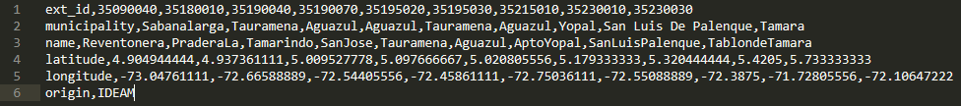

Illustration 8 Import File municipalities and seasons

Imported to the system files are stored within the website administration in the Data / Imports folder, the file name is composed of the date (YYYYMMDDHHMMSS format), an antenombre (-state-mws-) and ends with the name of own file was uploaded.

In subsequent chapters it will be described as performing individual registration of each of the entities described in this secion.

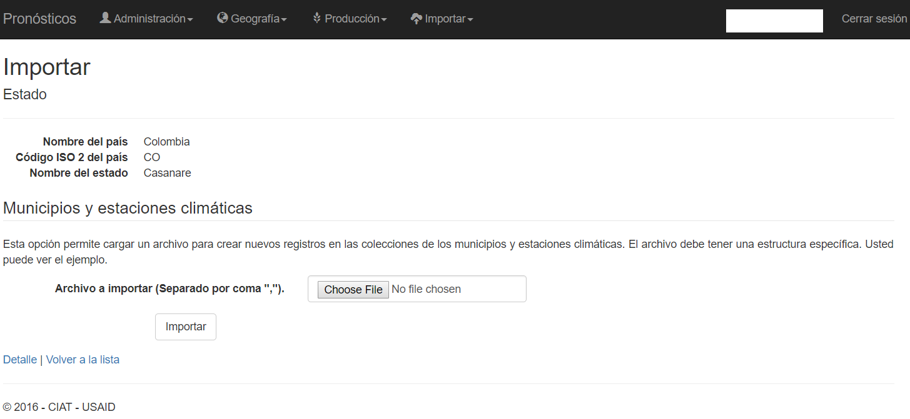

Illustration 9 Import municipalities and seasons

#### CPT configuration

The CPT is a configuration tool to set the parameters to be sent to the model climate prediction. This configuration must be done for all departments registered in the database.

To access this option, you must enter the module states, then click on the Settings link state to which you want to add configuration parameters.

The configuration is done per quarter for each state. For each of these should set the number of modes in canonical correlation, number of modes in x, number of modes and gamma transformation and theoretical regions. All fields are required. During the generation of the forecast the central month of each quarter is taken.

Quarters of the year are represented as follows:

* DJF = December - January - February
* JFM = January - February - March
* fma = February - March-April
* mam = March - April - Mayo
* amj = April - May - June
* mjj = May - June - July
* JJA = June - July-August
* jas = July - August - September
* aso = in August - September - October
* are = September - October - November
* ond = October - November - December
* NDJ = November - December - January

To add regions must press the button Add region. Each time the button is pressed, the system will enable the fields below to add the coordinates. A region consists of two pairs of coordinates to generate rectangle, the first two fields (latitude and longitude) define the lower left corner, while the other two fields (latitude and longitude) define the upper right corner.

At the bottom of the application available configurations are shown at the time. You can delete the settings by clicking on the Delete button. Elimination is logical.

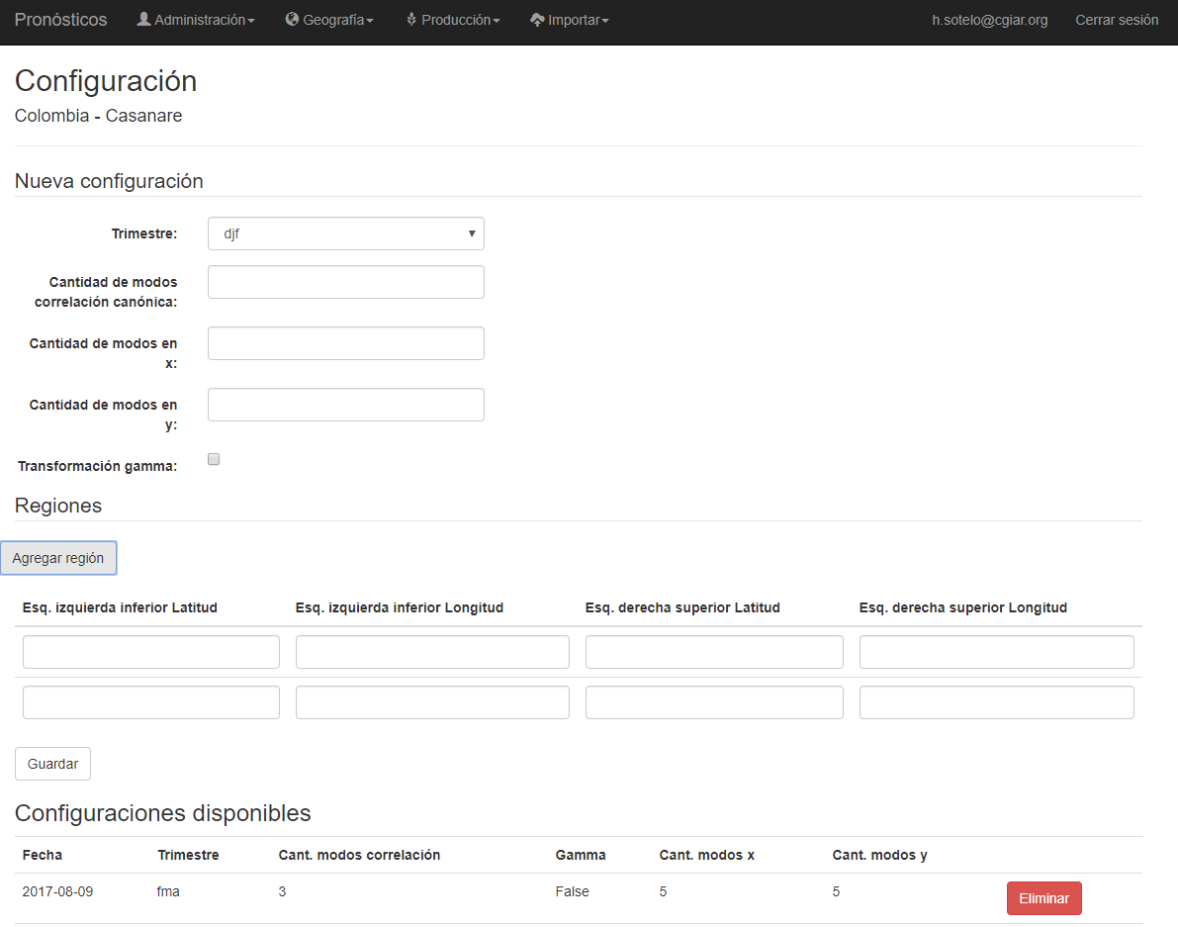

Illustration 10 CPT parameters set

The system has the following rules to correctly generate climate prediction:

* You must have a configuration for each quarter by each state.
* It should be noted that for the amount of correlation modes and number of modes and the value must not exceed the number of weather stations for that department.
* Each quarter must have at least one region.
* The maximum number of regions that can be added are twofold.
* Regions can not overlap each other.

### Municipalities

In the module allows the administration of municipalities which of these are available or not on the platform forecasts. Here you can add, edit, delete and list all the municipalities that are in the system. To add a municipality you must have registered before a state. Disposal in this module is logical.

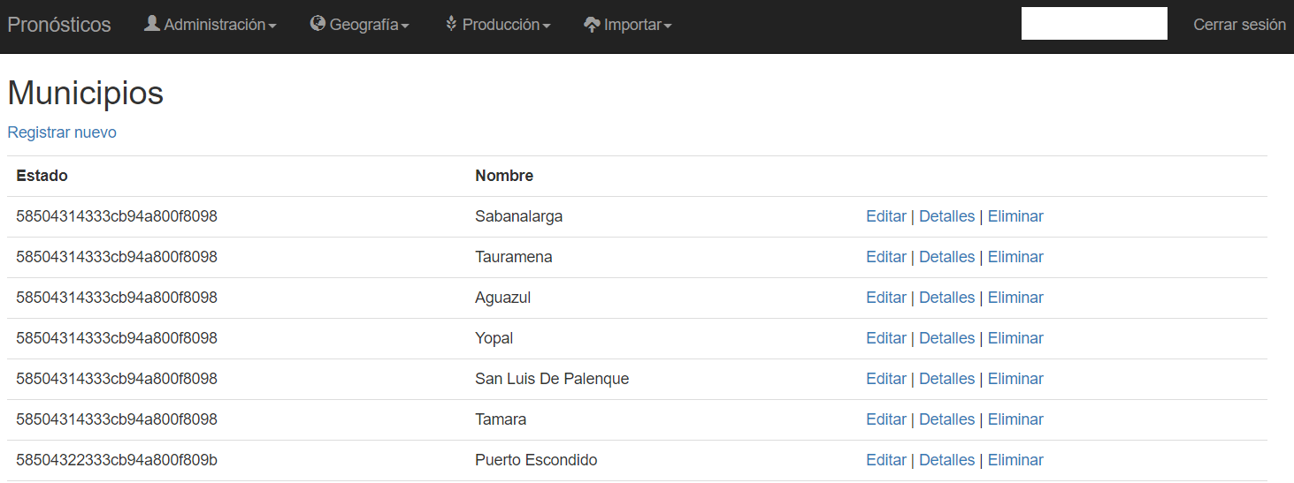

Illustration 11 module municipalities

Required fields:

* The state is the department which is associated with the municipality
* The name of the town is the proper name of the town
* **Visible** sets whether to display or not on the website of forecasts

In the section states it described as an import of several municipalities using a flat file.

This option is available for users who have the roles of ADMIN, CLIMATOLOGIST.

### Seasons

In the module seasons which allows the administration of these are available or not on the platform forecasts. Here you can add, edit, delete and list all the weather stations that are in the system. To add a weather station it must be registered before a municipality. Disposal in this module is logical.

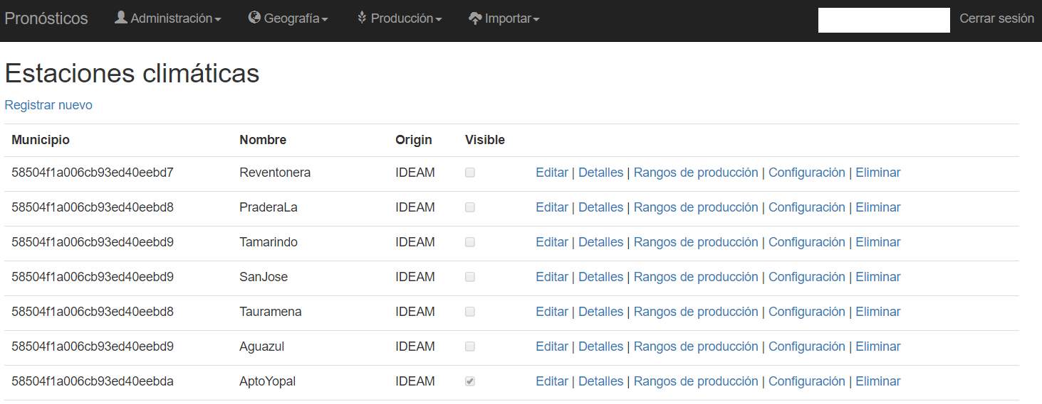

Illustration 12 Module seasons

Required fields:

* The municipality is the municipality which is associated climate station
* The name of the weather station is the proper name of this
* The source states who provides information
* The external code is the code of the station provider station
* **Visible**sets whether to display or not on the website of forecasts. It is also used to find out which stations are going to make climate forecast
* Latitude geographical coordinates set to the station location
* The length set in geographic coordinates the station location

optional fields:

* It sets the level elevation in meters above sea level where the station is.

Elevation despite being an optional field, is required to fill it stations in which it is planned schedule generation agroclimate forecast for rice cultivation.

In the section of states it described as an import of several seasons using a flat file.

This option is available for users who have the roles of ADMIN, CLIMATOLOGIST.

#### Production rates

Production ranges allow you to manage production levels of the different cultures that have occurred historically in weather stations. This serves to give users a glimpse of the production thresholds presented in the town of different crops. No need adding thereto this information to all stations. There may be several levels per crop season, however it is recommended to have five levels for each crop. This does not intervene at all during the process of generating agro-climatic forecast, it is only used for display themes.

To access this option, you must enter the module seasons, then click on the link production rates of the station to which you want to add production levels.

The configuration is performed for each crop. For each of these should be assigned the description, lower limit and upper limit. The unit of measurement to be used in this case are Kg / ha. Levels are generally added: Low, Regular, Normal, Good, Excellent; however, their values ​​depend on each region. For the lowest level of all the lower limit should be zero (0), while the highest level for the upper limit should be a very large number, we recommend placing 99999. All fields are mandatory.

At the bottom of the application ranges by culturing available at the time shown. You can delete a range by clicking on the Delete button. Elimination is logical.

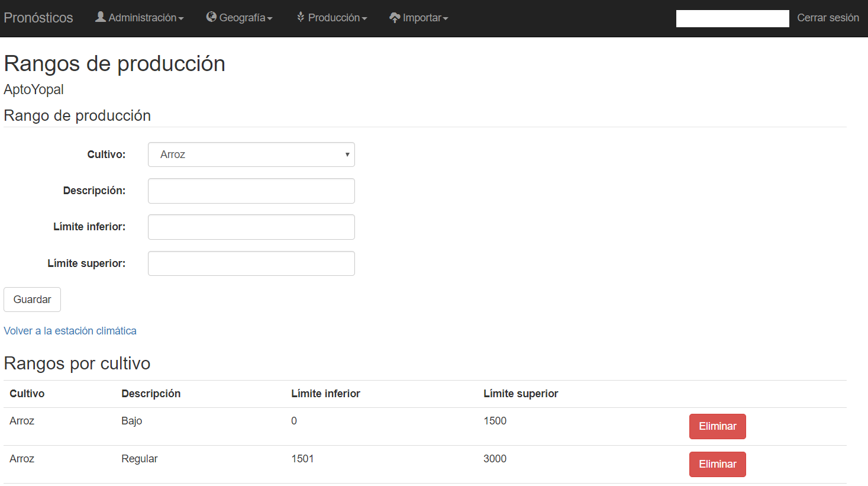

Illustration 13 Manage production rates by weather station

#### Configuration

Configuration is a tool that allows you to add files that later will be used for the generation process climate prediction.

To access this option, you must enter the module seasons, then click on the Settings link station to which you want to add configuration parameters.

A configuration file consists of two attributes within the application: name and file. The name allows you to identify where the application should use this setting, this is a specific value for the system to take this into account; later in each of the configuration options available the name should be given as interest will be detailed. The file is that file to be used at some point as a parameter of the process of generating forecasts.

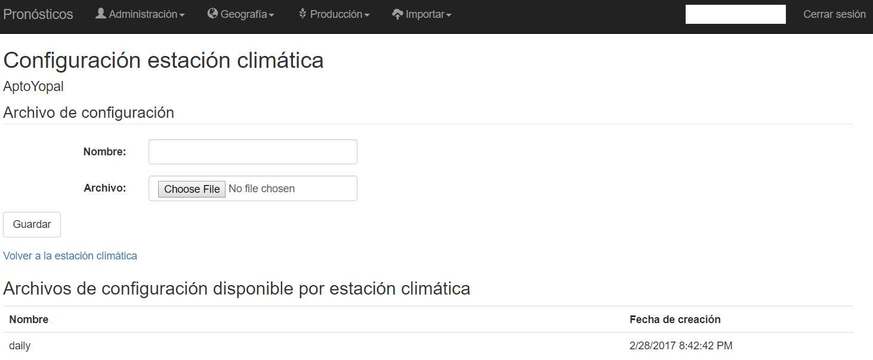

Illustration 14 Station configuration parameters

At the moment the only configuration that is being used is that of daily historical data files. These files are required for resampling process during the generation of climate prediction. The name should be given to this configuration is daily. The system has the following rules to correctly generate the resampling:

* This file should contain the information of at least 30 years of historical data.
* Takes this data are: day (day), month (month), year (year), maximum temperature (t_max), minimum temperature (T_MIN), precipitation (PREC) and solar radiation (sol_rad).
* Line 1 is the header file must be in the following format:

day, month, year, t_max, T_MIN, prec, sol_rad

* The following lines must contain the information for this season. Example:

1,1,1980,30.67449154,22.67449154,0,16.37537505

* The units of measure for each variable are: t_max = ° C, T_MIN = ° C, prec = mm, sol_rad = MJ / m²d

The following is an example of how it would file for a station with few records:

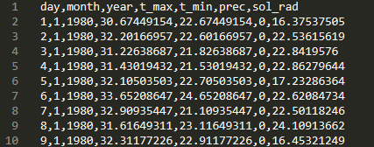

Illustration 15 Daily configuration file for a station

Imported to the system files are stored within the website administration in the Data / Configurations folder, the file name is composed of the date (YYYYMMDDHHMMSS format), an antenombre (-wsconf-), the id of the weather station, one antenombre (-) and ends with the file name itself was uploaded.

## Production

This section allows management parameters crop application. The configuration options for crops are crops, cultivars (varieties) and soils.

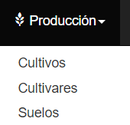

Illustration 16 Crop menu

### Crops

The module crops which allows administration of these are available or not on the platform forecasts. Here you can add, edit, delete and list all crops that are in the system. Disposal in this module is logical.

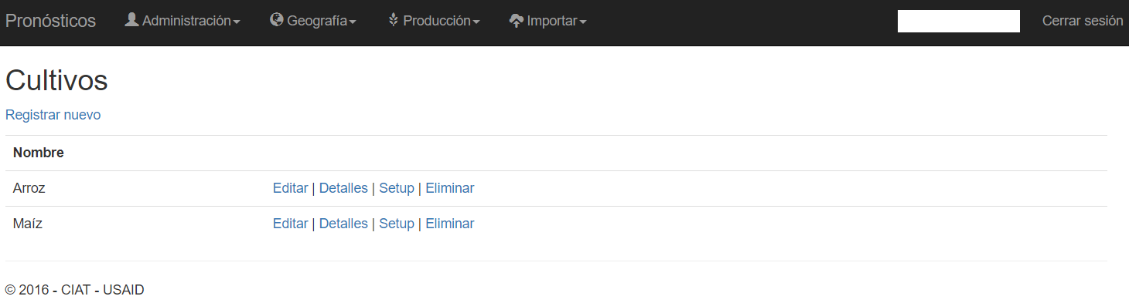

Illustration 17 Module crops

Required fields:

* The crop name is a description of this

Currently there are only two models that are calibrated crops: rice and corn. For rice Oryza model is implemented, while for corn DSSAT used.

This option is available for users who have the roles of ADMIN, IMPROVER.

#### Setup

The setup is the choice of crop module that allows configuration of crops for the generation of agroclimatic forecasts. Before performing a configuration for any crop, you must have previously registered the weather station, farming and soil.

To access this option, you must enter the module crop, then click on the Setup link crop that you want to add the different configurations.

The configuration is performed for each crop. For each of these must be assigned the weather station, cultivate, soil, days and configuration files. On the web portal only those weather stations will be listed. To add configuration files must be pressed click the Add File button. At the bottom of the application ranges by culturing available at the time shown. You can delete a range by clicking on the Delete button. Elimination is logical.

The days field is to represent the range of dates in which you can make the agroclimatic prognosis between planting dates. If you want to see the change that can occur daily in each planting dates, the value to go there is 1; but on the contrary, what is desired is to observe the variation that occurs weekly, the value to go there is in July.

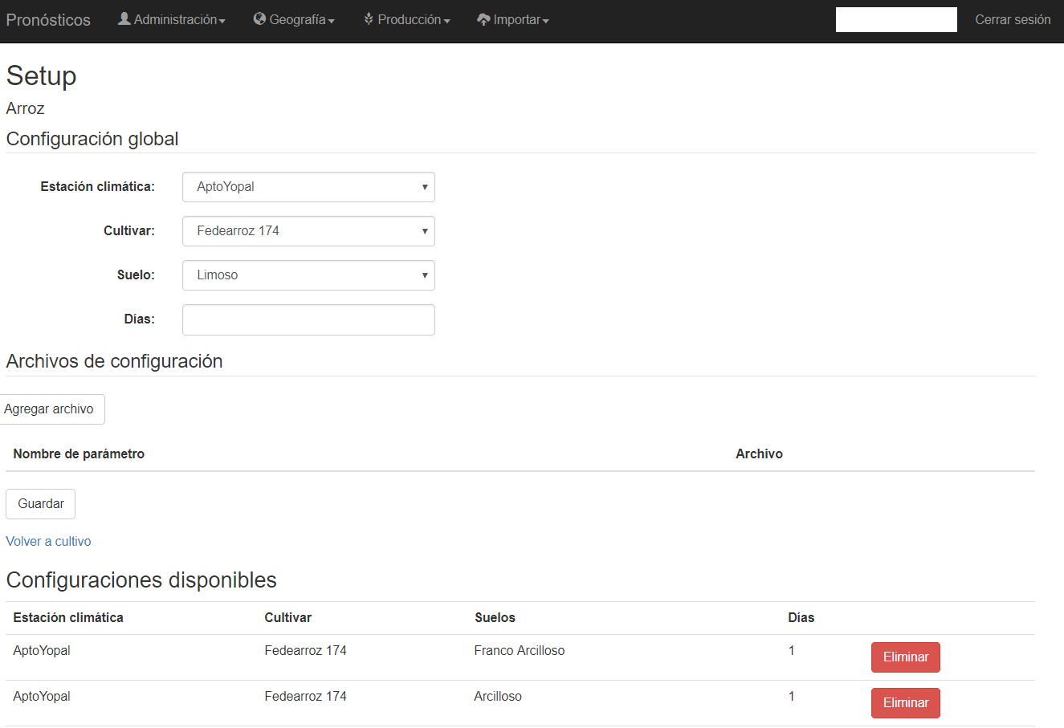

Illustration 18 Setup crop

Files to be added for each file found in the following chapters of this document.

##### Oryza configuration files

For configuration files Oryza is necessary to have 4 files that make up the run for the region, these files are:

* coordenadas.csv (Archive with the coordinates for the region)
* * .Crp (Data File culture model for rice growing)
* * .Sol (File with soil information)
* * .Exp (Archive experimental data)

Next, an example of each of the files is presented primarily as must be configured to the correct specification of the model run. Any error that is present within each of these files, will present a failed run, that is to say the agroclimatic forecast for that region will be generated.

File "coordenadas.csv" (always be saved with this name) should be constructed as follows (comma separated file):

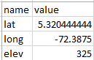

Illustration 19

(Lat = latitude, long = long, elev = lifting)

You should know that decimal separators in this case are given by '.' (point).

File "* .crp" must contain the parameters of crop growth once calibrated (remember that this file is the process of hard work of the researcher). On the recommendation the file name can be the name of the variety (eg F2000.crp).

File "* .sol" soil data for the model soil water balance. The name of making tribute to the textural characteristic of the soil (eg Franco_Limoso_Arcilloso.sol).

Finally, the experimental file "* .exp" which contains all crop management. Because forecasts are made runs, should not be included irrigation options. The file name can refer to the area or region you are configuring the run (eg LOCO.exp). It is necessary to note that the configuration of the run was performed in experimental mode and no evaluation as is conventional calibration, ie:

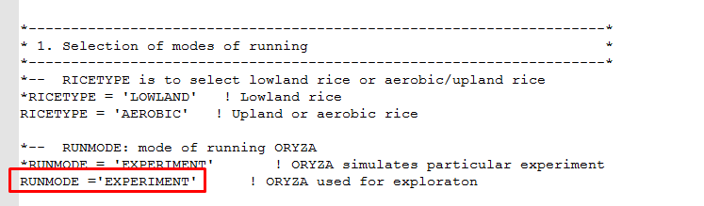

Illustration 20

Then those files required to run will be shown.

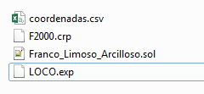

Illustration 21

Without the files shown above it is impossible to make a forecast agroclimatic run. Climate information is not necessary in this step and add the module automatically takes climate forecast in the previous module loaded.

##### DSSAT configuration files

Configuration files must respect certain patterns DSSAT both the name of the configuration files as within them, then the description of the necessary files will be displayed to set a run for a region. In this case it is necessary to have the following 5 files:

* MZCER046.CUL
* MZCER046.ECO
* MZCER046.SPE
* SOIL.SOL
* planting_details.csv

Next, an example of each of the files is presented primarily as must be configured to the correct specification of the model run. Any error that is present within each of these files, will present a failed run, that is to say the agroclimatic forecast for that region will be generated.

The file that defines parameters grow, it must always be saved as "MZCER046.CUL" and the name in the file is a generic name given as "crop00" should always be named cultivar otherwise Platform it will not generate the agroclimatic prognosis. That is to say:

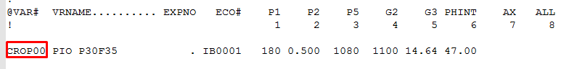

Illustration 22

In addition, the name must match the ecotype "MZCER046.ECO" file that is:



Illustration 23

On the left side of the graph shows the .cul file and left the .eco file, showing where the names must match for the correct specification of the model run culture. The .spe file should not medicate (leave the default standard that comes in installing DSSAT).

The .sol file, should always be called "SOIL.SOL" and within its configuration must be created as:

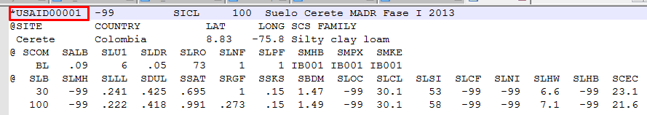

Illustration 24

It is important that within the file is accessed SOIL.SOL him as "* USAID00001" because it is a generic name created for the proper functioning of the platform.

Finally, to set up the run for the region is critical to have this information in the file "planting_details.csv" a file separated by commas and decimals. '' (point). Next, an example in crop management for a particular region is presented.

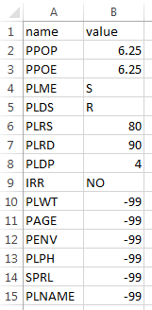

Illustration 25

The above parameters must be set by the expert to the region and that any errors will cause the agroclimatic forecast is generated.

### cultivars

The module cultivars which allows the administration of these are available or not on the platform forecasts. Here you can add, edit, delete and list all cultivars found in the system. Disposal in this module is logical.

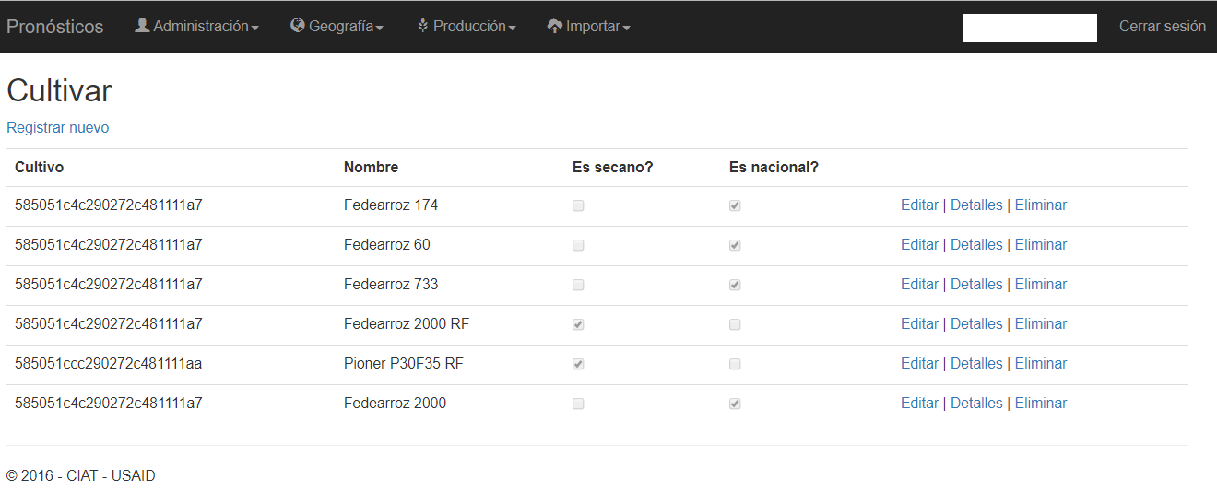

Illustration 26 cultivate module

Required fields:

* The variety name is a description of the cultivar
* Culturing is encompassed by this
* The order sets out how to list these, including higher the number will be listed first
* **It is dry** It indicates whether farming is rain-fed or irrigated
* **It is a national** It indicates whether the material is domestic or imported

This option is available for users who have the roles of ADMIN, IMPROVER.

### floors

The module allows management of soils which of these are available or not on the platform forecasts. Here you can add, edit, delete and list all soils found in the system. Disposal in this module is logical.

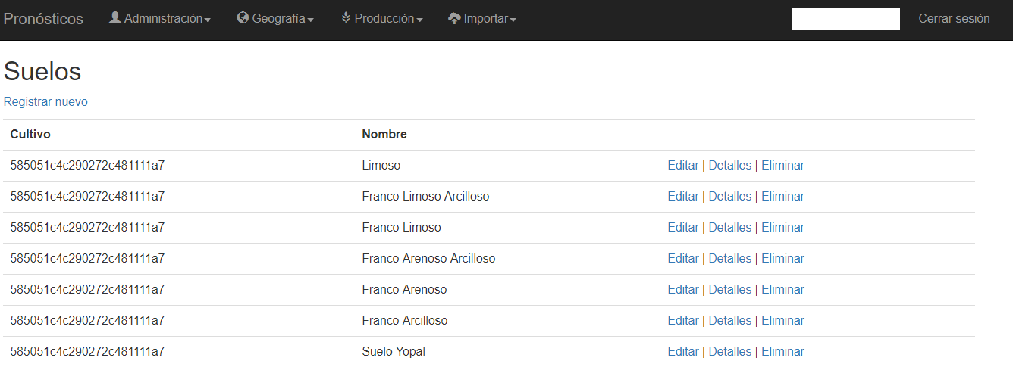

Illustration 27 Soil module

Required fields:

* The name of the soil is a description of this
* Culturing is encompassed by this
* The order sets out how to list these, including higher the number will be listed first

This option is available for users who have the roles of ADMIN, IMPROVER.

## to import

This section allows the import of historical data to the platform. The data that can be imported are historical climate, weather and historical production.

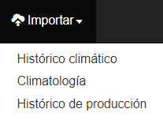

Illustration 28 import menu

### historical climate

The module import historical climate allows up flat files with monthly information on historical data for weather. Each file can contain information from one or more weather stations at once. Data must be specific to each station. Climate variables that can be imported include precipitation (prec), maximum temperature (t_max), minimum temperature (T_MIN) and solar radiation (sol_rad). Data import only a single variable per file is allowed. When importing must be specified if weather stations are to be searched by name or by other external code.

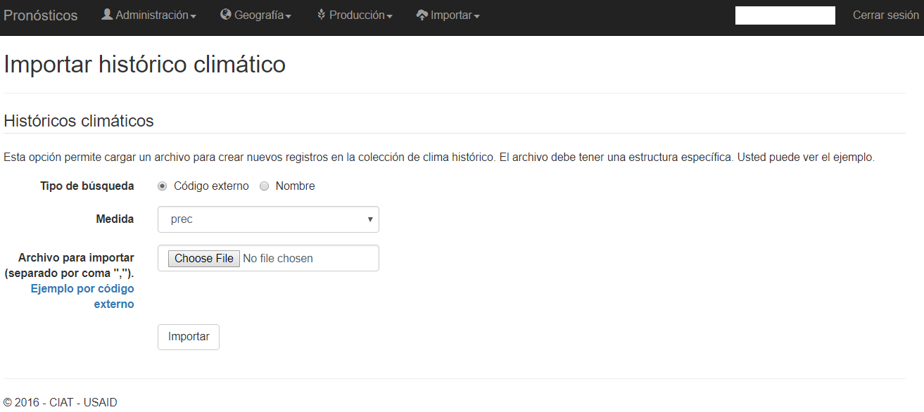

Illustration 29 I module import historical climate

To import should prepare a flat file with information for each weather station. This file must be in CSV format. You must select the type of search, you can choose between external code or the name of the station. Then you must choose the climate variable (measure) to be imported. Following this you must select the file you want to import. Finally you press on the Import button.

The file must have the following format:

* Line 1 must start with the year and month headers, then go to the search parameter as stations have chosen. Each station must be separated by commas. The following example is parameterized by external codes:

year, month, 26055070,26060020,26070110

* The following lines contain information for year, month and values ​​for each station. Example:

1981,1,75.1,38,10

The following example shows the information three stations:

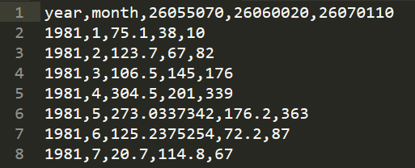

Illustration 30 Climate Historical Archive

Historical data are very important for the platform, these data are used for the generation process climate prediction and information display. These data are used in the component probabilistic prediction.

This option is available for users who have the roles of ADMIN, CLIMATOLOGIST, IMPROVER.

### Climatology

Weather module lets you upload files with information planes historical monthly averages of weather. Each file can contain information from one or more weather stations at once. Data must be specific to each station. Climate variables that can be imported include precipitation (prec), maximum temperature (t_max), minimum temperature (T_MIN) and solar radiation (sol_rad), relative humidity (rel_hum), precipitation first tertile (prec_ter_1) and precipitation second tertile (prec_ter_2 ). When importing must be specified if weather stations are to be searched by name or by other external code.

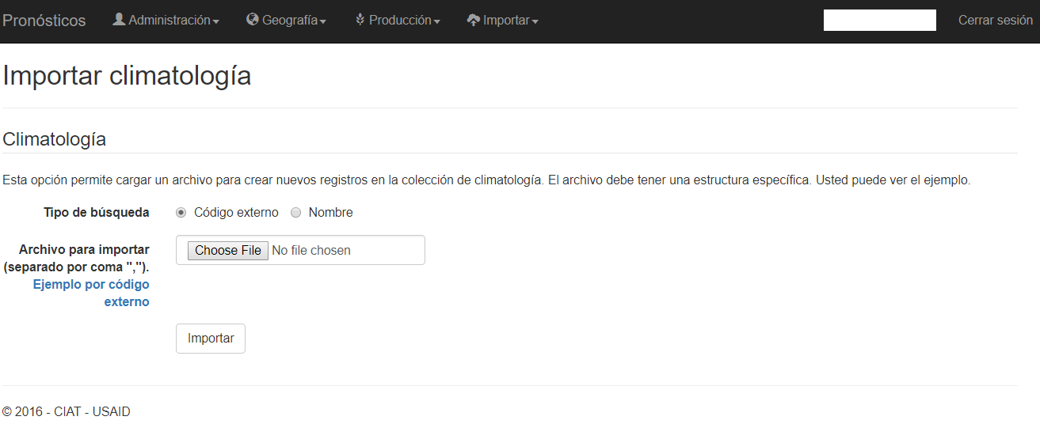

Illustration 31 Import Module weather

To import should prepare a flat file with information for each weather station. This file must be in CSV format. You must select the type of search, you can choose between external code or the name of the station. Following this you must select the file you want to import. Finally you press on the Import button.

The file must have the following format:

* Line 1 must start with the measure and month headers, then go to the search parameter as stations have chosen. Each station must be separated by commas. The following example is parameterized by external codes:

measure, month, 21245040,26115040,13085010

* The following lines contain the information measure, month and values ​​for each station. Example:

t_max, 1,28.88639,31.21029,32.22629

The following example shows the information of three stations and two climate variables:

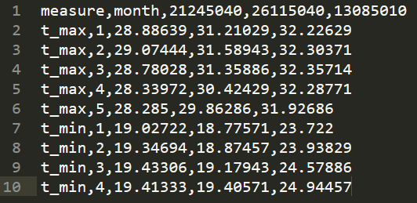

Illustration 32 Climatology file

This information is used for displaying weather information. These values ​​allow you to set the historical average of each of the variables of climate. Precipitation variables first tertile (prec_ter_1) and second tertile precipitation (prec_ter_2) define the normal range of precipitation.

This option is available for users who have the roles of ADMIN, CLIMATOLOGIST, IMPROVER.

### Historical production

The historical production module lets you upload files with historical information planes crop production in each locality. Each file can contain information from one or more weather stations at once. The data can be observed or modeled. Each file requires you to specify a data source. This information is used for displaying information agroclimática.

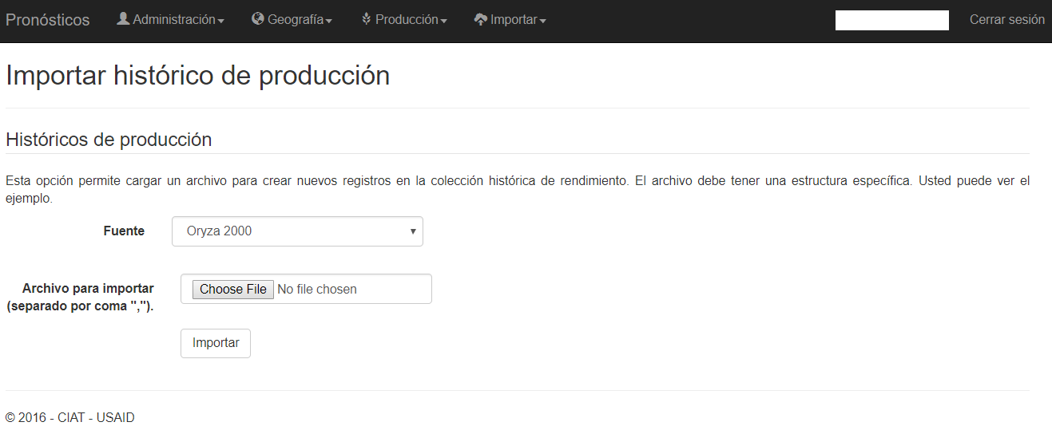

Illustration 33 I import module production history

To import should be prepared a flat file with information for each weather station, soil and grow. This file must be in CSV format. You must select the source of the information. Following this you must select the file you want to import. Finally you press on the Import button.

The file must have the following format:

* Line 1 must have the following header:

weather_station, soil, cultivating, start, end, measure, median, avg, min, max, quar_1, quar_2, quar_3, conf_lower, conf_upper, sd, perc_5, perc_95, coef_var

* + weather_station weather station code =
  + code = soil soil
  + cultivar = cultivate code
  + start = date of initial seeding. Format (yyyy-MM-dd)
  + end = final planting date. Format (yyyy-MM-dd)
  + measure = Measure (yield_14 - Production at 14% humidity, yield_0 - Production at 0% moisture, d_har - Days to harvest d_dry - Days drying prec_acu - Accumulated rainfall, t_max_acu - Maximum temperature accumulated, t_min_acu - Minimum temperature accumulated , bio_acu - accumulated biomass, et_acu - cumulative evapotranspiration)
  + median = Medium
  + avg = average
  + min = Minimum
  + max = Maximum
  + quar_1 = First Quartile
  + quar_2 = Second quartile
  + quar_3 = Third quartile
  + conf_lower = Lower limit of confidence interval
  + conf_upper = Upper limit of confidence interval
  + sd = standard deviation
  + perc_5 = Percentile 5
  + perc_95 = 95th Percentile
  + coef_var = Coefficient of Variation
* The following lines contain information of historical production. Example:

58504f5d006cb93ed40eec4e, 5851ab2c47847d1f144b83ff, 58505210c290272c481111b1,1980-01-01,1980-01-05, yield_14,8582.2,8582.2,8582.2,8582.2,8582.2,8582.2,8582.2,0,0,0,8582.2,8582.2,0

The following example shows historical production data:

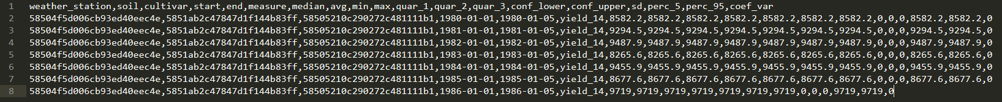

Illustration 34 Historical Archive Production

This option is available for users who have the roles of ADMIN, CLIMATOLOGIST, IMPROVER.

# FORECASTS generation process

1. You can find a list of ISO 2 country codes in <http://www.nationsonline.org/oneworld/country_code_list.htm>
2. You can find more information about the CSV format in <https://es.wikipedia.org/wiki/Valores_separados_por_comas>
3. These ids (or codes) are given by the vendor or owner of the information of the weather station